Code:  
//To swap two numbers using pass by reference

#include <stdio.h>

void swap(int \*,int \*);

int main()

{

int x,y;

printf("Enter the two values of x and y\n");

scanf("%d %d",&x,&y);

swap(&x,&y);

printf("x=%d, y=%d",x,y);

return 0;

}

void swap(int \*p,int \*q){

int temp=\*p;

\*p=\*q;

\*q=temp;

}

Output:

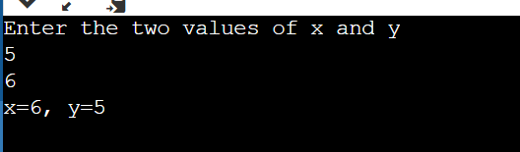

Conclusion: The code to swap two numbers was studied and implemented successfully.